**Experiment 6:** *To understand Gauss Seidel Method to find solution to system of linear equations*

**Exercise:**

1. Using MATLAB/SciLab solve the following Gauss Seidel Method

/* Gauss-Seidel Method

by Keivalya Pandya on SciLab

*/

*// FUNCTION for Gauss Seidel Method*

function **C**=seidel(**a**, **x**, **b**)

n = size(**a**, "r");

for j = 1:n

d = **b**(j);

for i = 1:n

if j~=i

d = d - **a**(j,i)\***x**(i);

end

**x**(j) = d/**a**(j,j);

end

end

**C** = **x**;

endfunction

*// FUNCTION to give number of iterations. Here, 10 is enough.*

function K(**a**, **x**, **b**)

for i = 1:10

**x** = seidel(**a**, **x**, **b**);

disp(**x**);

end

endfunction

*// Q1*

printf("\n\t Q1 Output\n")

x = [0,0,0];

a = [3, 0.1, -0.2; 0.1, 7, 0.3; 0.3, -0.2, 10];

b = [7.85, -19.3, 71.4];

K(a, x, b);

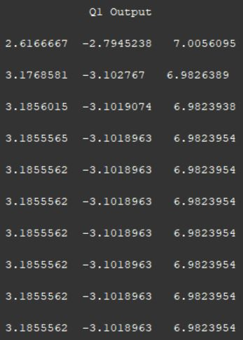

*// Q2*

printf("\n\t Q2 Output\n")

x = [0,0,0];

a = [10, 2, -1; -1, -9, 2; 1, 1, 5];

b = [27, -61.5, -21.5];

K(a, x, b);

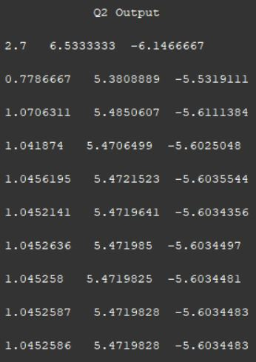

*// Q3*

printf("\n\t Q3 Output\n")

x = [0,0,0];

a = [4, -3, 5; 2, -1, -1; 1, 1, 4];

b = [34, 6, 15];

K(a, x, b);

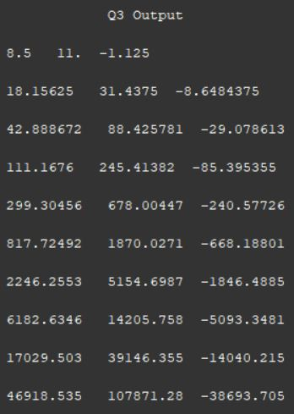

*// Q4*

printf("\n\t Q4 Output\n")

x = [0,0,0];

a = [2, -1, 5; 2, 1, 1; 1, 3, 1];

b = [15, 7, 10];

K(a, x, b);

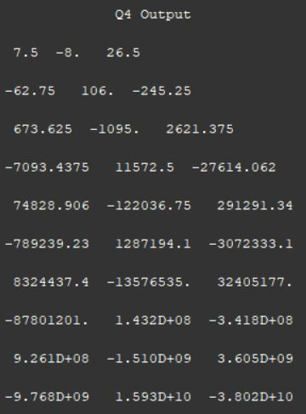

*// Q5*

printf("\n\t Q5 Output\n")

x = [0,0,0];

a = [15, 3, -2; 2, 10, 1; 1, -2, 8];

b = [85, 51, 0];

K(a, x, b);

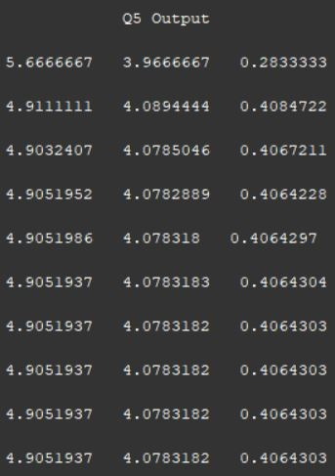

*// Q6*

printf("\n\t Q6 Output\n")

x = [0,0,0,0];

a = [10, 2, -1, -1; -2, 10, -1, -1; -1, -1, 10, 2; -1, -1, -2, 10];

b = [3, 15, 27, -9];

K(a, x, b);

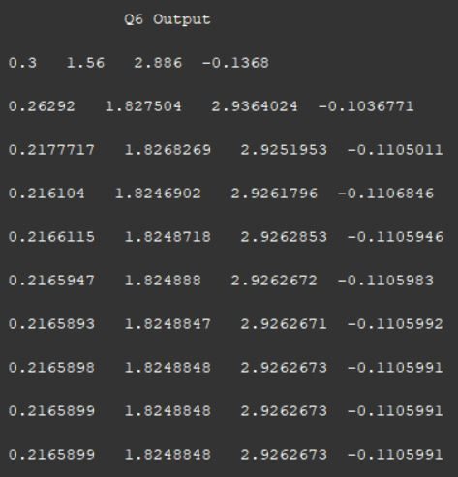

*// Q7*

printf("\n\t Q7 Output\n")

x = [0,0,0,0];

a = [4, 2, 0, 0; 2, 8, 2, 0; 0, 2, 8, 2; 0, 0, 2, 4];

b = [4, 0, 0, 0];

K(a, x, b);

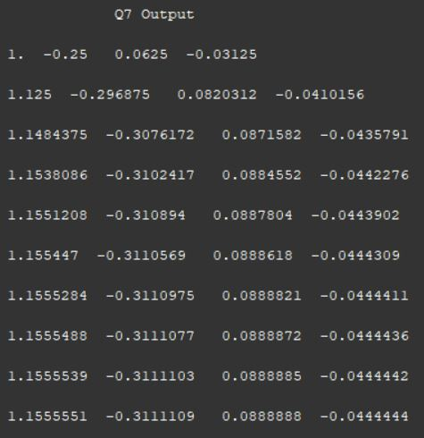

*// Q8*

printf("\n\t Q8 Output\n")

x = [0,0,0,0];

a = [4, 2, 0, 0; 2, 8, 2, 0; 0, 2, 8, 2; 0, 0, 2, 4];

b = [4, 0, 0, 14];

K(a, x, b);

